Ideation Phase
Brainstorm & Idea Prioritization Template

Date | 5/July/2026
Team ID
Project Name | Book A Doctor
Maximum Marks | 4 Marks

Brainstorm & Idea Prioritization Template:
The team brainstormed several ideas to improve the healthcare appointment process. The main focus was to reduce waiting time, simplify appointment booking, and provide an efficient system for both patients and doctors. Different features were discussed, and the most practical and user-friendly ideas were selected for implementation in the Book A Doctor application.
Step-1: Team Gathering, Collaboration and Select the Problem Statement
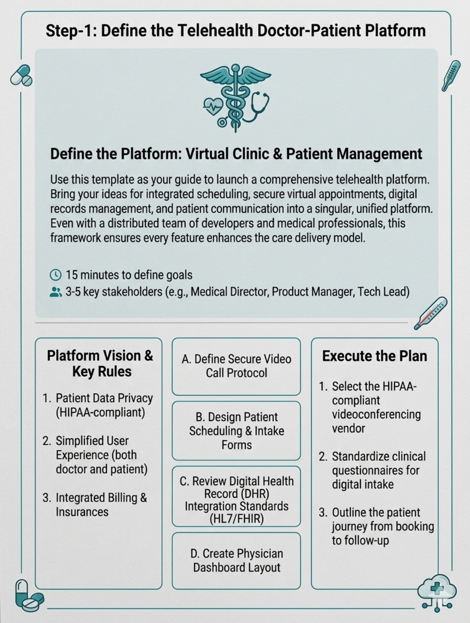
Step-2: Brainstorm, Idea Listing and Grouping
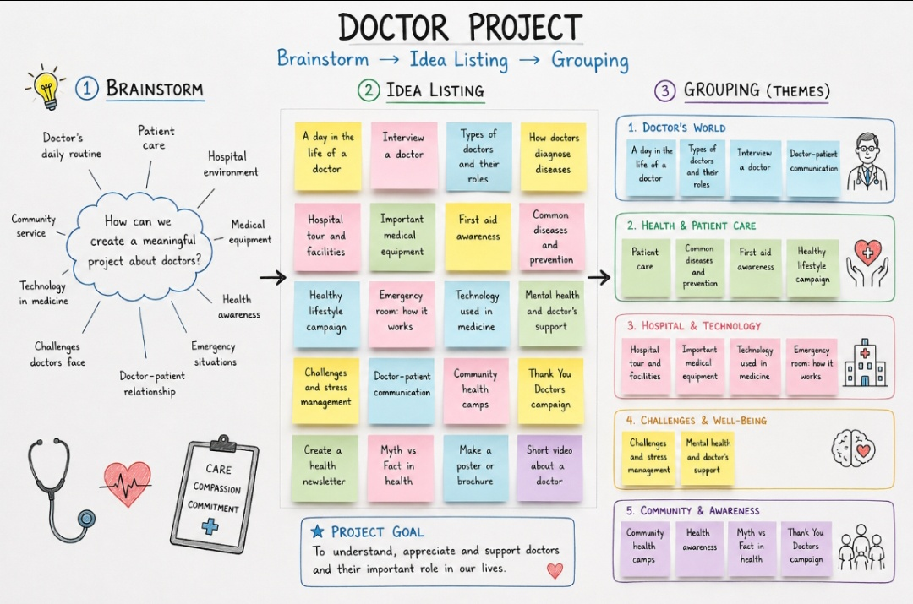

Step-3: Idea Prioritization
